
Year 9

Test 1-Section 1

No resources allowed

Name: ______________________ Class: ______ Time: 20 minutes Total Mark(1):____/20
Total Mark(1+2):____/66

- Evaluate the following:
[5 marks]
- $5^{2}$

- $7^{1}$

- ${12}^{0}$

- $3^{-2}$

- ${\frac{1}{2}}^{-5}$

- Match the following expressions
[5 marks]

$$2(6x-3)$$ |  | $$12x-3$$
$$-4(1-3x)$$ |  | $$12x-4$$
$$3\left(3x-1\right)+3x$$ |  | $$12x-6$$
$$14x-2(x-3)$$ |  | $$12x-1$$
$$2(4+3x)+3(2x-3)$$ |  | $$12x+6$$

- Circle the expressions which are equivalent to $6a^{2}b$
[4 marks]

$$2a+3ab$$ | $$\frac{6a^{4}b^{2}}{a^{2}b}$$ | $$8a^{2}b^{2}-2b$$ | $$2ab×3a$$
$$a^{2}×b+{6b×a}^{2}$$ | $$2a×3ab$$ | $$10a^{2}b-{4a}^{2}b$$ | $$\frac{18a^{2}b}{3a^{2}b}$$

- Expand and simplify the following expressions
[ 6 marks]
- $5(2y+1)$

- $7\left(2+a\right)-4a$

- $p(p+4)$

- $-2b(5b-3)$


Year 9

Test 1-Section 2

Resources allowed – Calculator and 1A4 page of notes

Name: ______________________ Class: ______ Time: 40 minutes Total Mark:_____/46

Questions 1 to 10 are multiple choice. Circle your answer.
[10 marks]

- is equal to:

A 4 B 8 C 16

D 25 E 32

- is equivalent to:

A B C

D E

- simplifies to:

A −2 B −1 C 0

D 2 E 7

- simplifies to:

A B C

D E

- When we expand brackets, we use the distributive law. Which of the following does not represent the distributive law?

A a(b + c) = ab + ac B −a(b + c) = −ab − ac C −a(b − c) = −ab − ac

D −a(b − c) = −ab + ac E a(b − c) = ab − ac
- Which of the following expressions is equivalent to $2\left(5m+1\right)$?

A $7m+1$ B $10m+1$ C$10m+2$

D $12m$ E $11m$

- Which of the following expressions is equivalent to $5c+10$?

A $2c×3c+10$ B $5c+c+10$ C$15c$

D $c+16+4c-6$ E $2c+16-3c-6$

- The expression $4x+6+7x+12$ can also be written as

A $10x+19$ B $11x+18$ C$18x+11$

D $29x^{2}$ E $29x$

- Which expression is equivalent to $3x^{2}-12x+x^{3}$ ?

A $3(x^{2}-4x+x^{2})$ B $3x(x-4+x^{2})$ C$x^{2}(3-12+x)$

D $x(3x-12+x^{2})$ E $3x^{2}(1-4x+x)$

- Which expression below gives the perimeter of the following shape?
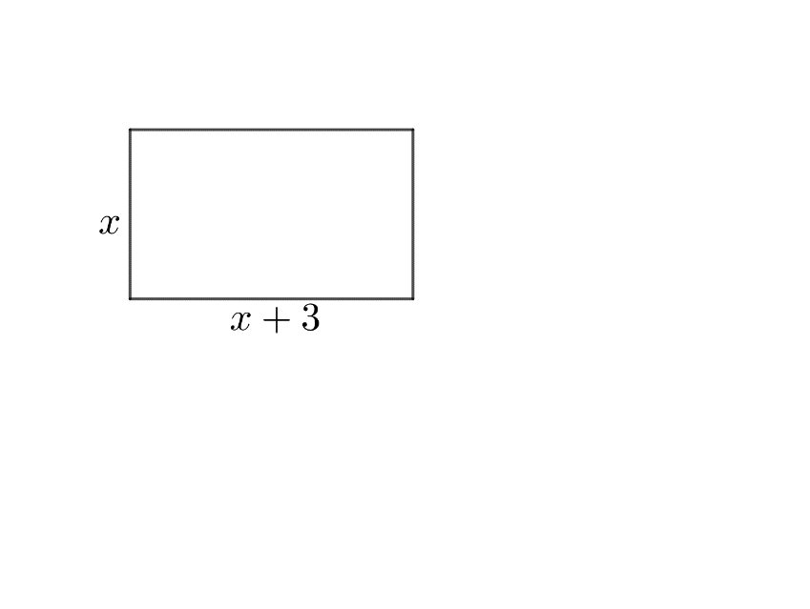

A $x(x+3)$ B $x+(x+3)$ C$2(2x+3)$

D $4x+12$ E $x^{2}+3x$

- George invests $3 500 in a bank that offers an interest rate of 4.5%. He plans to leave the money invested for 2 years.
[3 marks]
- How much simple interest does George earn?

- What is the total of George’s investment after 2 years?

- Simplify each of the following expressions (leave your answers in index form)
[4 marks]
- ${12}^{5}×12^{3}$

- $x^{7}×x^{9}$

- $p^{8}÷p^{5}$

- ${\left(y^{7}\right)}^{2}$

- Simplify the following expressions:
[4 marks]

- ${9t}^{5}÷{3t}^{3}$

- ${(2k^{4})}^{3}$

- $\frac{30x^{5}y^{6}z}{24x^{3}y^{3}}$

- Fully factorise the following expressions
[4 marks]
- $5t+10$

- $h^{2}-6h$

- $-2e^{2}-4e$

- $xy^{2}+3x^{2}y$

- Calculate the area of the following shapes
[4 marks]
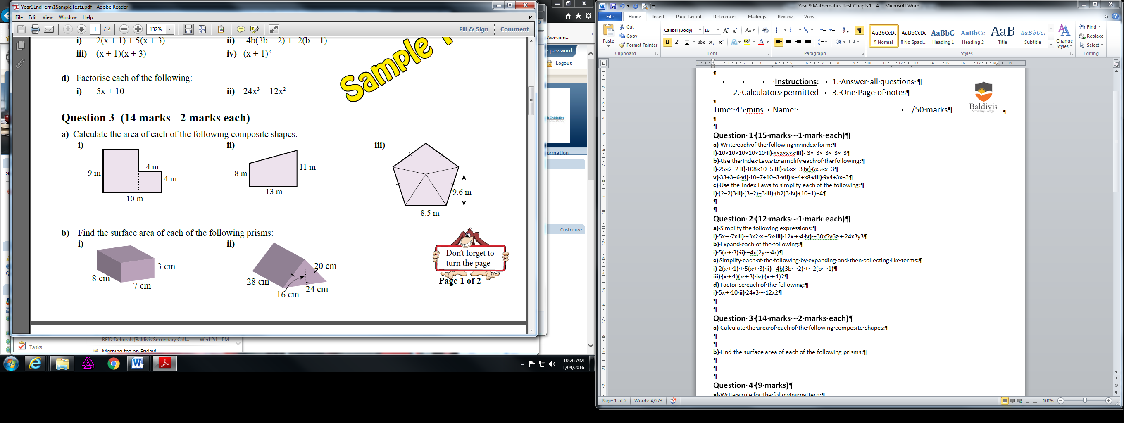



- Expand and simplify the following
[12 marks]

- $3k(k+1)-4(2k-5)$

- $(x+3)(x+7)$

- $(y-6)(y-5)$

- ${(p+9)}^{2}$

- Calculate the Total surface area of the following shape
[3 marks]
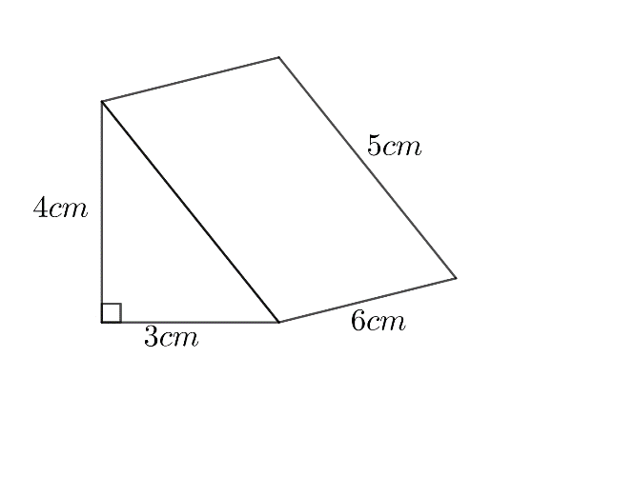

- How long will it take for an investment of $8 000 at an interest rate of 3% to earn $1 200 in simple interest?
[2 marks]

End of Paper.

